8.TURING MACHINE – SUBTRACTION

Design :

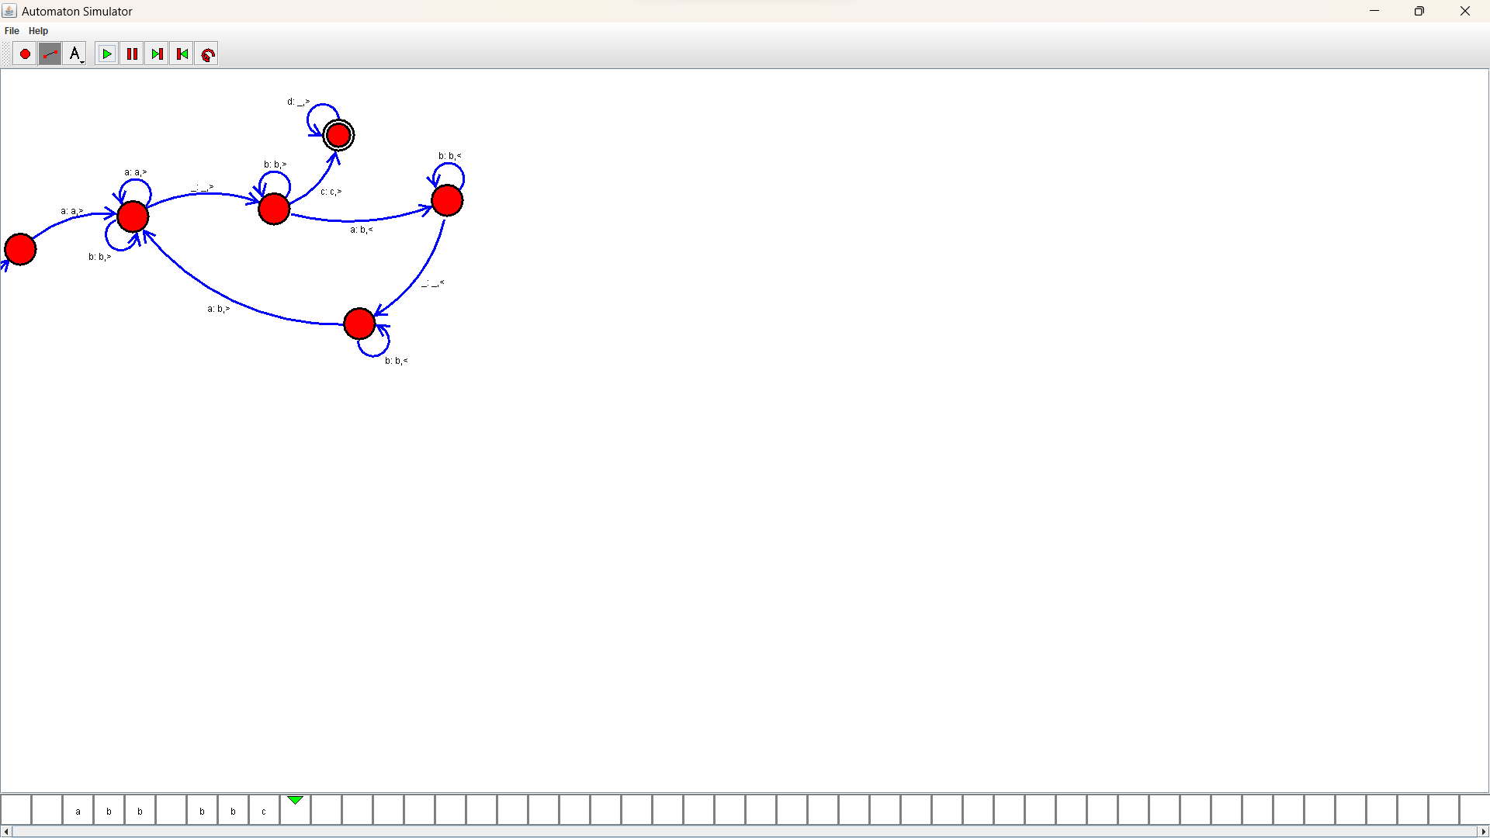

Output :